EXPT NO: 6 | IMPLEMENTATION OF LONG SHORT-TERM MEMORY (LSTM) FOR SENTIMENT ANALYSIS
DATE: 11-10-26

PRE-LAB QUESTIONS

1. Explain the working of Long Short-Term Memory (LSTM) networks in processing sequential data.

LSTM is a type of recurrent neural network designed to process sequential data and learn long-term dependencies. It uses a cell state to carry important information across different time steps. The input, forget, and output gates control the flow of information within the network. LSTM processes each element in a sequence while considering previously learned information. This makes it useful for tasks such as sentiment analysis, language translation, and text generation.

2. Discuss why LSTM is considered suitable for sentiment analysis of textual data.

LSTM is suitable for sentiment analysis because it can understand the sequence and context of words in a sentence. It remembers important information from earlier words while processing later words. This helps the model identify positive and negative expressions in movie reviews. LSTM can also learn long-term dependencies that influence the overall meaning of a review. Therefore, it can classify textual data into appropriate sentiment categories.

3. Explain the role of memory cells and gates in an LSTM network.

Memory cells store important information from previous time steps while processing sequential data. The forget gate decides which information should be removed from the cell state. The input gate controls which new information should be added to the memory. The output gate determines which information should be passed to the next layer. Together, these components help LSTM retain relevant information and make accurate predictions.

4. Explain the importance of tokenization during text preprocessing for sentiment analysis.

Tokenization is the process of dividing text into smaller units such as words or tokens. It helps convert sentences into a structured format that can be processed by a machine learning model. Each token can be assigned a unique integer index using a vocabulary. This makes it easier to represent reviews as numerical sequences. Proper tokenization improves the preparation of textual data for LSTM-based sentiment classification.

5. Why should textual data be converted into numerical representations before training an LSTM model?

Textual data must be converted into numerical representations because neural networks perform mathematical operations on numbers. Each word can be assigned an integer index using a tokenizer. These indices are then converted into dense vector representations through an embedding layer. Numerical sequences allow the LSTM model to learn patterns and relationships between words. This process enables the model to classify text into positive or negative sentiments.

AIM
To implement a Long Short-Term Memory (LSTM) neural network for sentiment analysis and classify textual data into appropriate sentiment categories based on the learned linguistic patterns.

SOFTWARE REQUIREMENTS
- Python
- TensorFlow / Keras / PyTorch
- Google Colab
- GitHub
- NumPy
- Matplotlib
- Pandas

OBJECTIVES
Students will be able to:
- Understand the architecture and working of Long Short-Term Memory (LSTM) networks.
- Understand the role of LSTM in processing sequential textual data.
- Perform text preprocessing techniques for sentiment classification.
- Convert textual data into numerical sequences suitable for LSTM models.
- Build and train an LSTM-based sentiment classification model.
- Evaluate the performance of the trained LSTM using appropriate classification metrics.
- Analyze the effectiveness of LSTM in learning contextual and sequential patterns from textual data.

PROCEDURE
PART A: DATASET PREPARATION
Perform the following tasks:
- Load a suitable sentiment analysis dataset such as the IMDB Movie Reviews dataset.
- Explore the dataset and examine sample reviews and their corresponding sentiment labels.
- Identify the positive and negative sentiment classes.
- Perform basic text preprocessing such as converting text to lowercase, if required.
- Remove unnecessary characters or symbols, if required.
- Tokenize the reviews into words.
- Build a vocabulary and assign unique integer indices to words.
- Convert the text reviews into numerical sequences.
- Apply sequence padding to obtain inputs of equal length.
- Split the prepared dataset into training and validation/testing datasets.

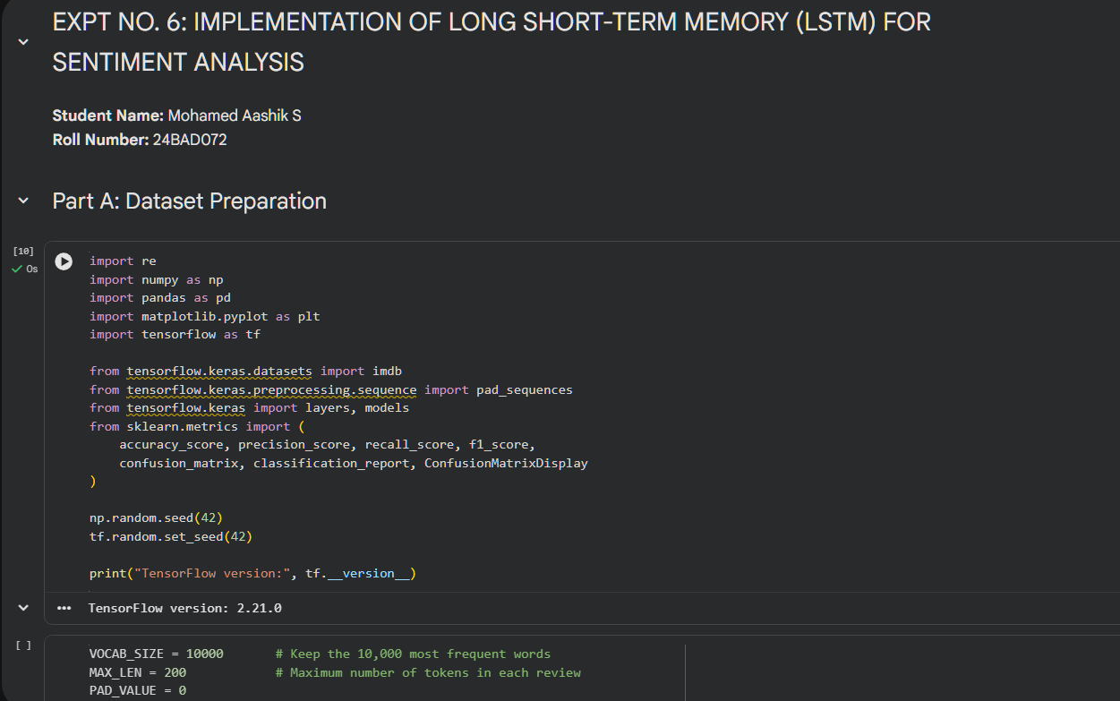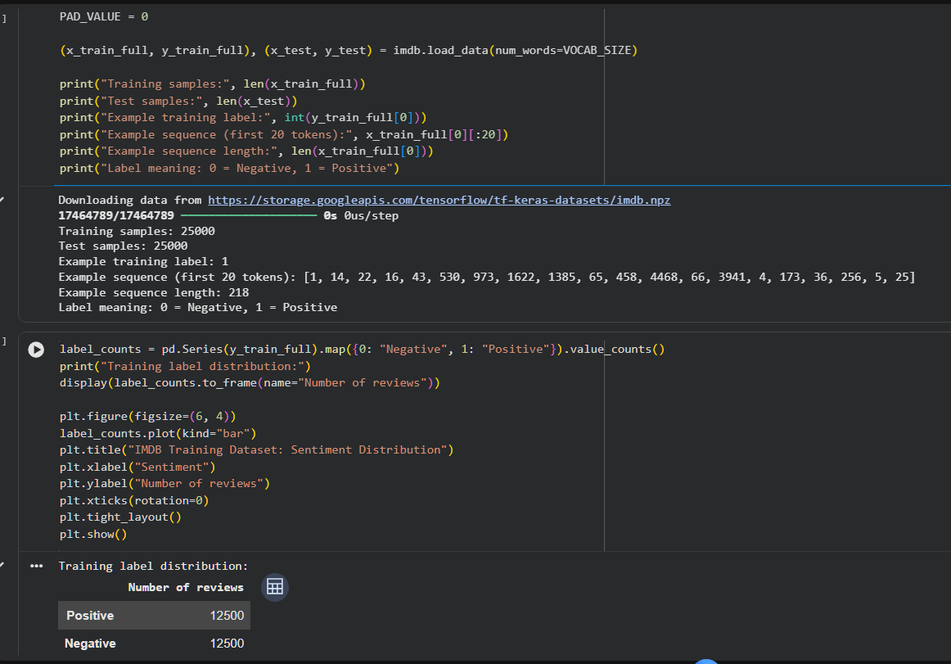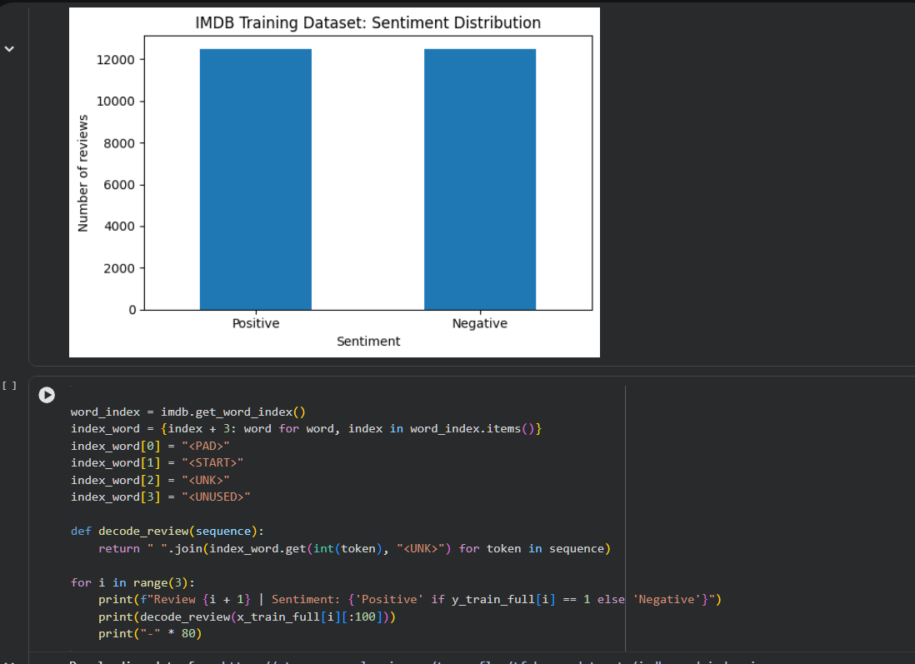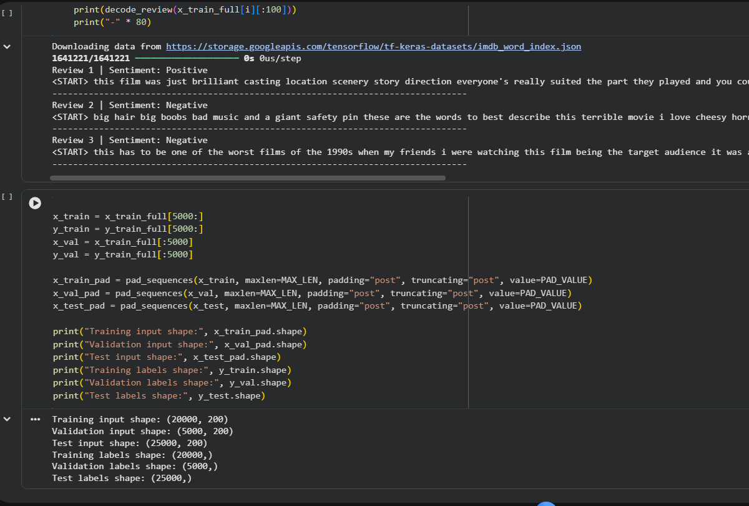
PART B: IMPLEMENTING THE LSTM MODEL
Perform the following tasks:
- Create an Embedding layer to convert words into dense vector representations.
- Add an LSTM layer to learn long-term sequential dependencies in the reviews.
- Add a Dense output layer for sentiment classification.
- Use an appropriate activation function such as Sigmoid for binary sentiment classification.
- Compile the model using an appropriate optimizer and loss function.
- Display the model architecture and model summary.

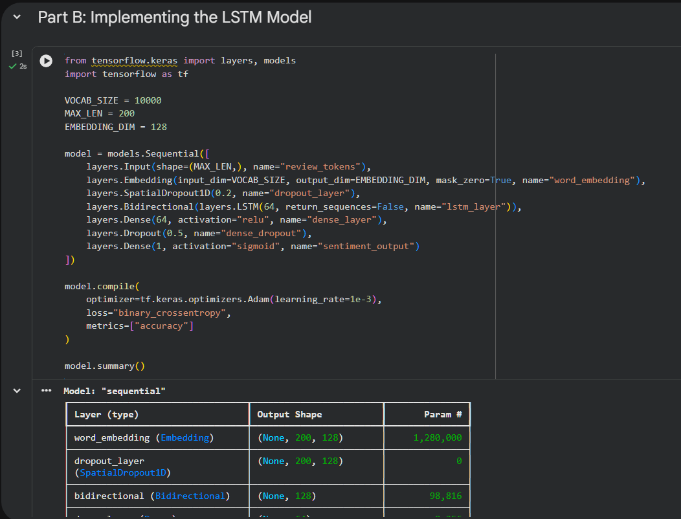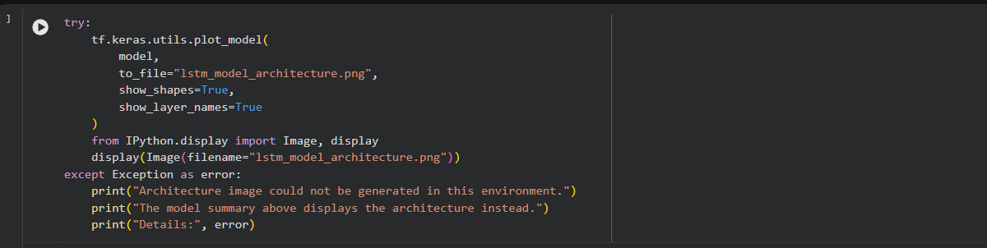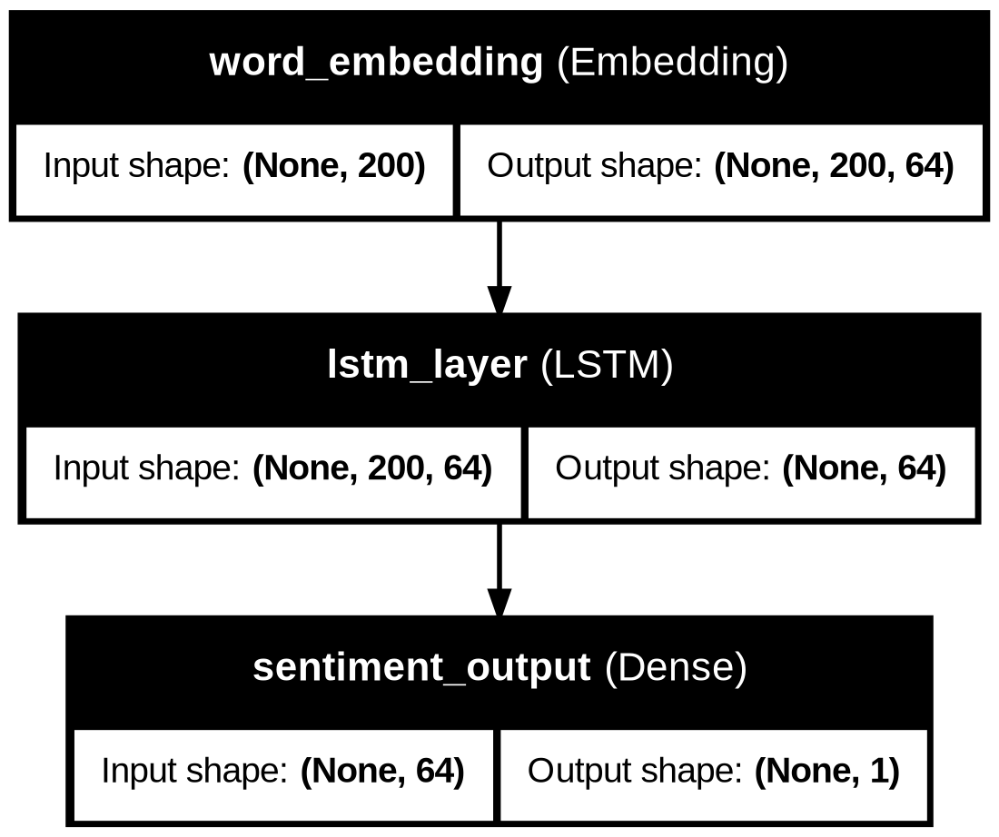
PART C: MODEL TRAINING AND PERFORMANCE EVALUATION
Perform the following tasks:
- Train the LSTM model using the prepared training dataset.
- Validate the model using the validation dataset.
- Record:
  - Training accuracy
  - Validation accuracy
  - Training loss
  - Validation loss
- Evaluate the trained model on the test dataset.
- Calculate suitable evaluation metrics such as:
  - Accuracy
  - Precision
  - Recall
  - F1-score
- Generate a confusion matrix to analyze the classification performance.
- Visualize:
  - Accuracy vs. Epoch
  - Loss vs. Epoch

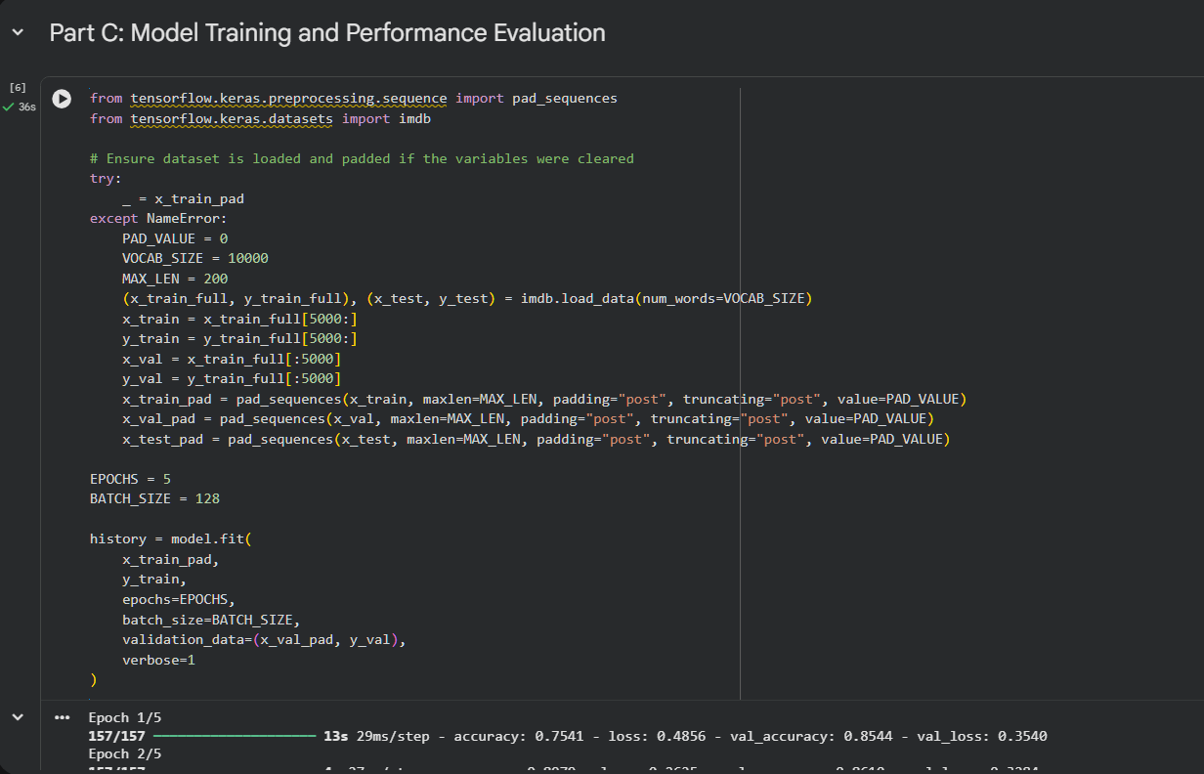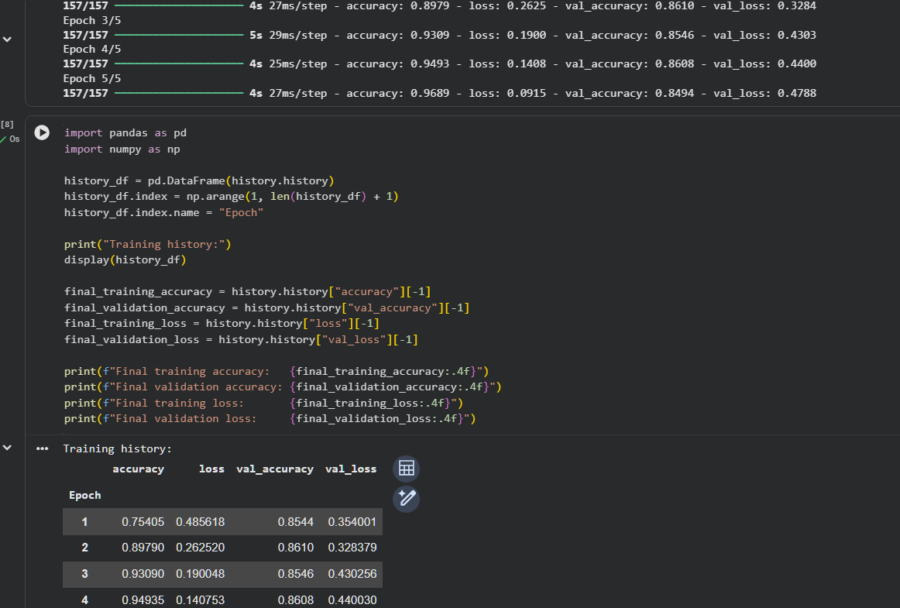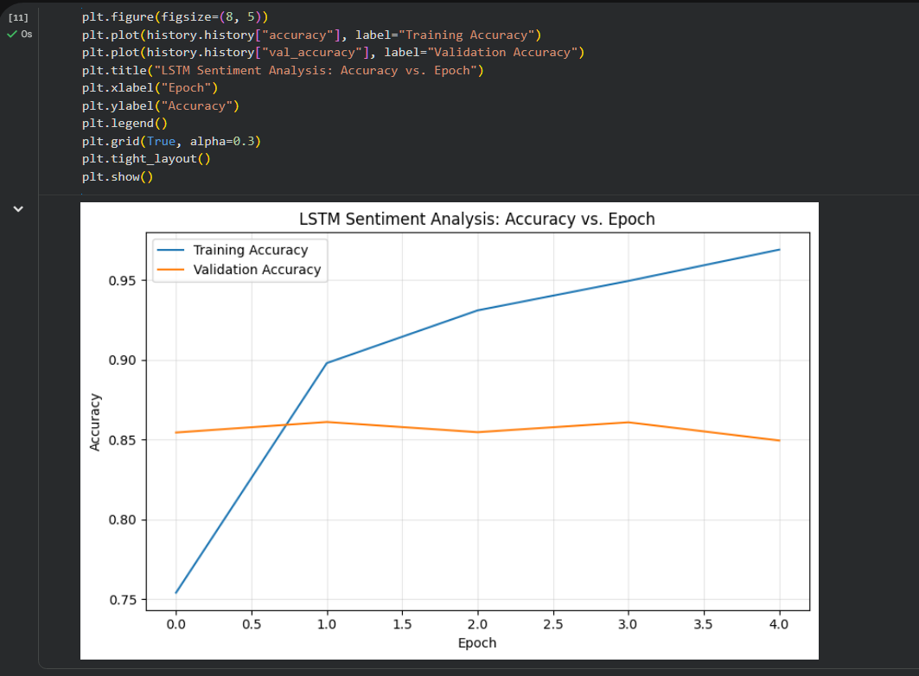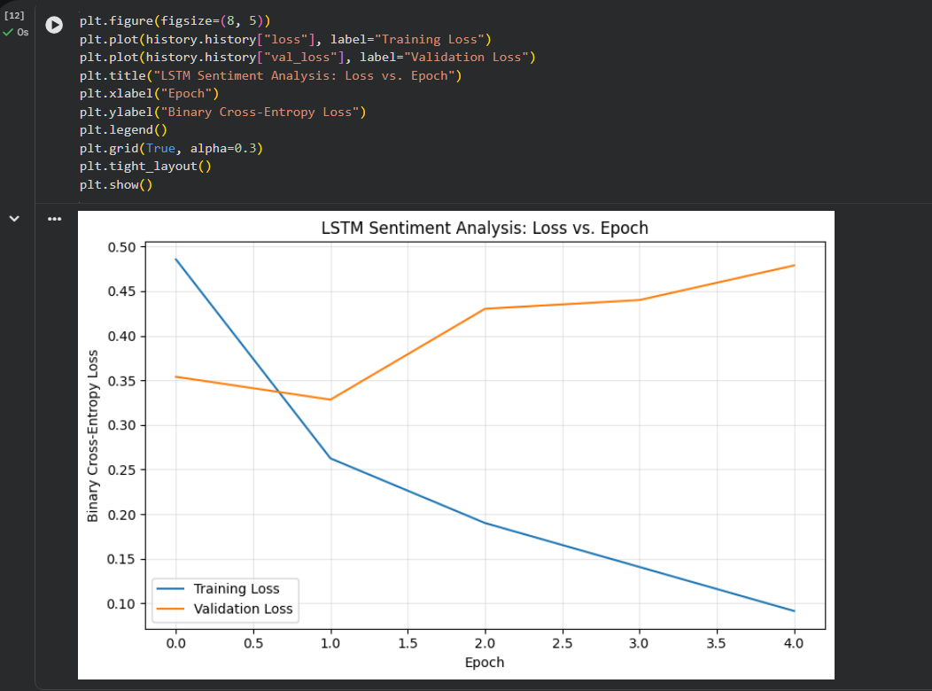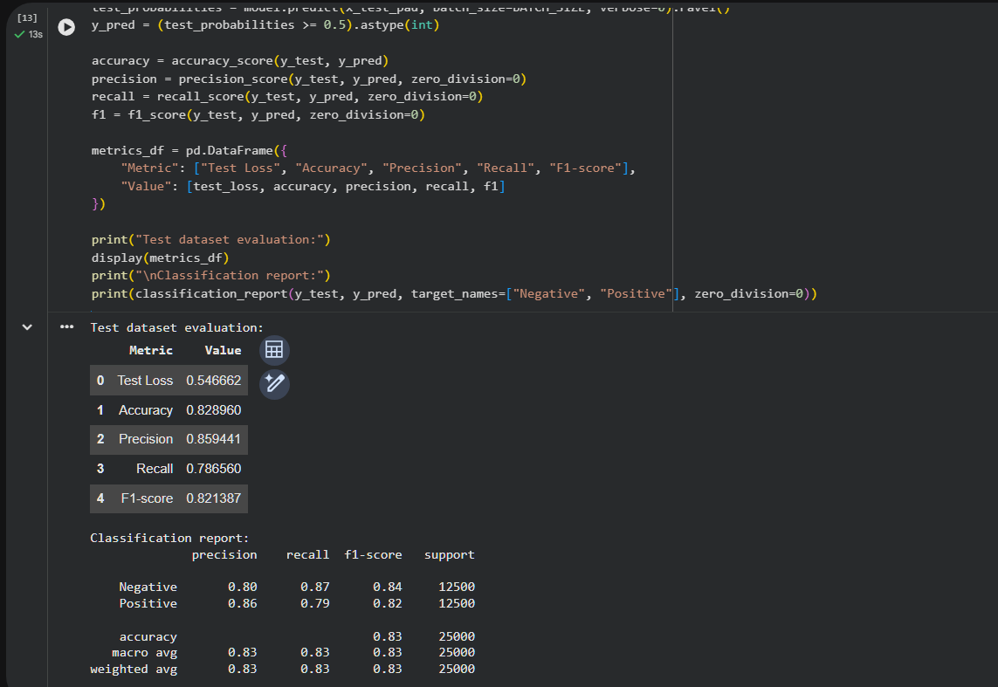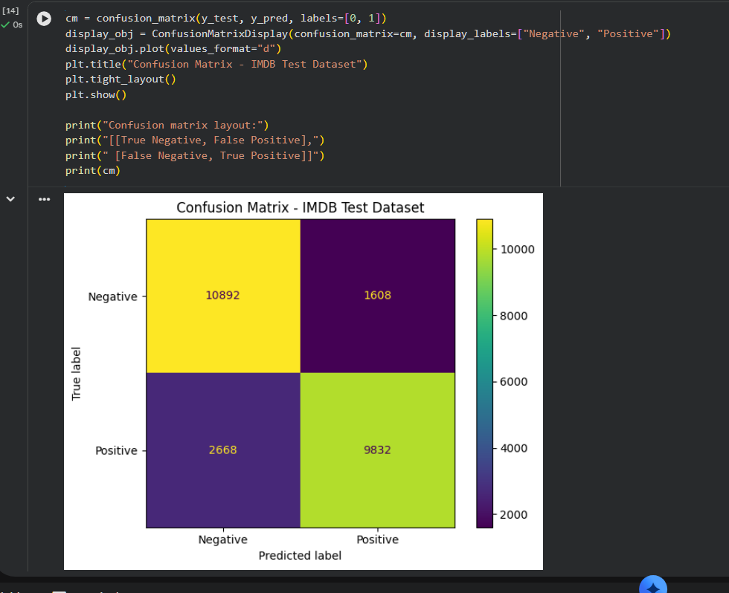
PART D: SENTIMENT PREDICTION AND DEEP LEARNING EXPERIMENT MANAGEMENT

Perform the following tasks:
- Provide new movie-review sentences as input to the trained LSTM model.
- Preprocess and tokenize the input text using the same vocabulary used during training.
- Apply sequence padding to the input text.
- Predict the sentiment using the trained LSTM model.
- Classify the input as Positive or Negative based on the predicted probability.
- Provide multiple review samples with different sentiments.
- Compare the predicted sentiment with the actual/expected sentiment.
- Analyze the coherence and correctness of the model predictions.
- Document the observations and upload the notebook to GitHub.

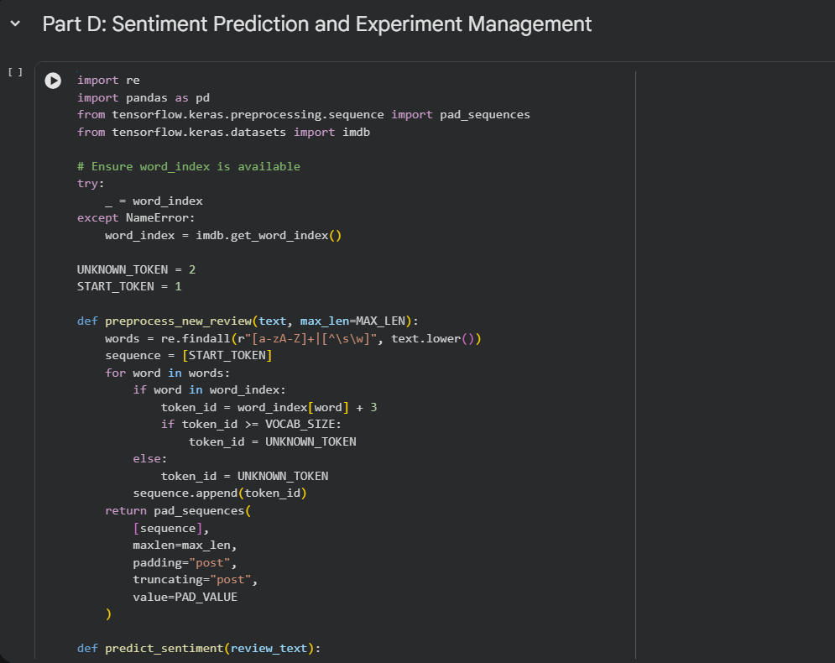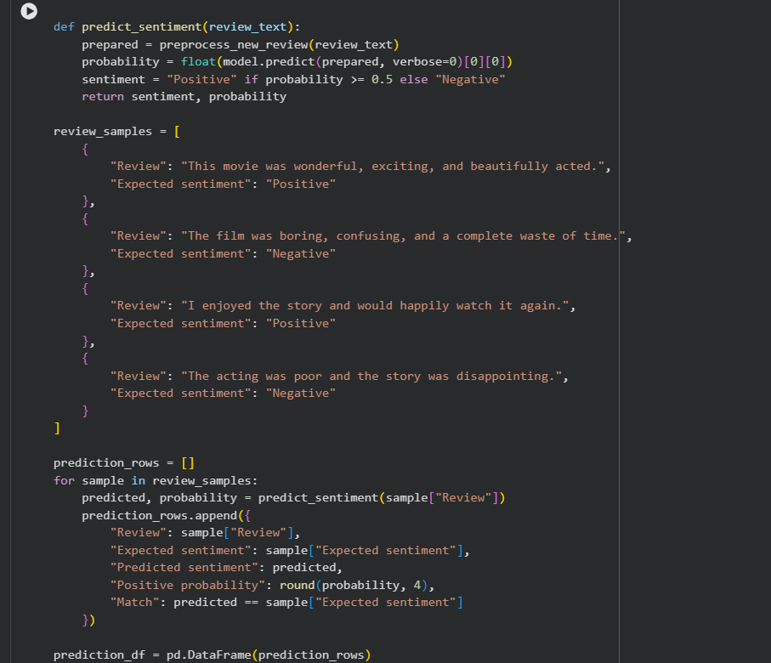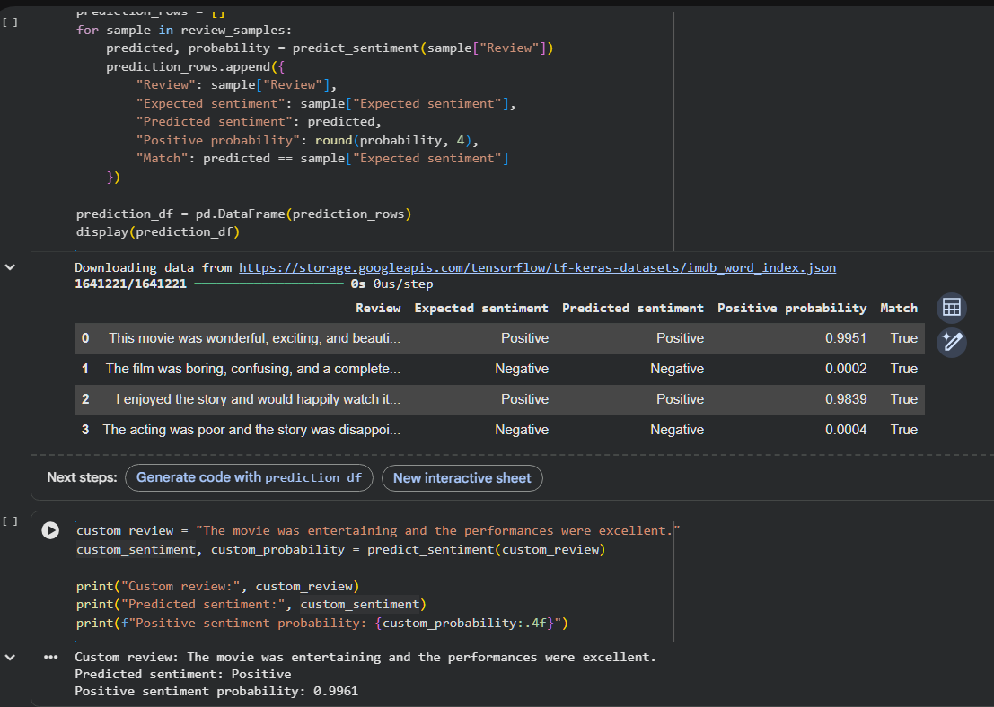

POST-LAB QUESTIONS

1. Explain how the cell state helps an LSTM retain information over long sequences.

The cell state acts as a memory pathway that carries information across multiple time steps. It allows the LSTM to preserve important information from earlier parts of a sequence. The forget gate removes unnecessary information, while the input gate adds useful new information. This controlled flow helps reduce the vanishing gradient problem found in traditional recurrent neural networks. As a result, LSTM can learn long-term dependencies and understand the context of lengthy text reviews.

2. Describe the functions of the input gate, forget gate, and output gate in an LSTM.

The input gate controls how much new information is stored in the cell state. The forget gate determines which existing information should be retained or discarded. The output gate selects the information from the cell state that is used to produce the current hidden state. These gates work together to manage the flow of information through the network. This mechanism enables LSTM to learn meaningful patterns from sequential data.

3. Discuss the effect of insufficient training epochs on the performance of an LSTM sentiment classification model.

Insufficient training epochs may prevent an LSTM model from learning important patterns in the training dataset. This condition is known as underfitting, where the model performs poorly on both training and unseen data. The model may fail to recognize complex relationships between words and their sentiments. As a result, training accuracy and validation accuracy may remain low. Increasing the number of epochs appropriately can improve performance, provided overfitting is avoided.

4. Explain one advantage of LSTM over a Simple RNN for sentiment analysis.

One major advantage of LSTM over a Simple RNN is its ability to learn long-term dependencies in sequential data. A Simple RNN may struggle to retain information from earlier words because of the vanishing gradient problem. LSTM uses a cell state and specialized gates to preserve important information for longer periods. This helps it understand relationships between words that are far apart in a sentence. Therefore, LSTM can provide better sentiment classification for complex and lengthy reviews.

5. Discuss how sequence length can affect the accuracy and computational requirements of an LSTM-based sentiment analysis model.

Sequence length determines the number of tokens processed by the LSTM for each text sample. Longer sequences preserve more contextual information but require greater memory and computational time. Shorter sequences reduce training time but may remove important words that influence sentiment. Choosing an appropriate sequence length helps balance classification accuracy and computational efficiency. Padding and truncation are commonly used to make input sequences suitable for efficient model training.

ASSESSMENT
Description | Max Marks | Marks Awarded
Pre Lab Exercise | 5
In Lab Exercise | 10
Post Lab Exercise | 5
Viva | 10
Total | 30
Faculty Signature

